Work to be done by each member

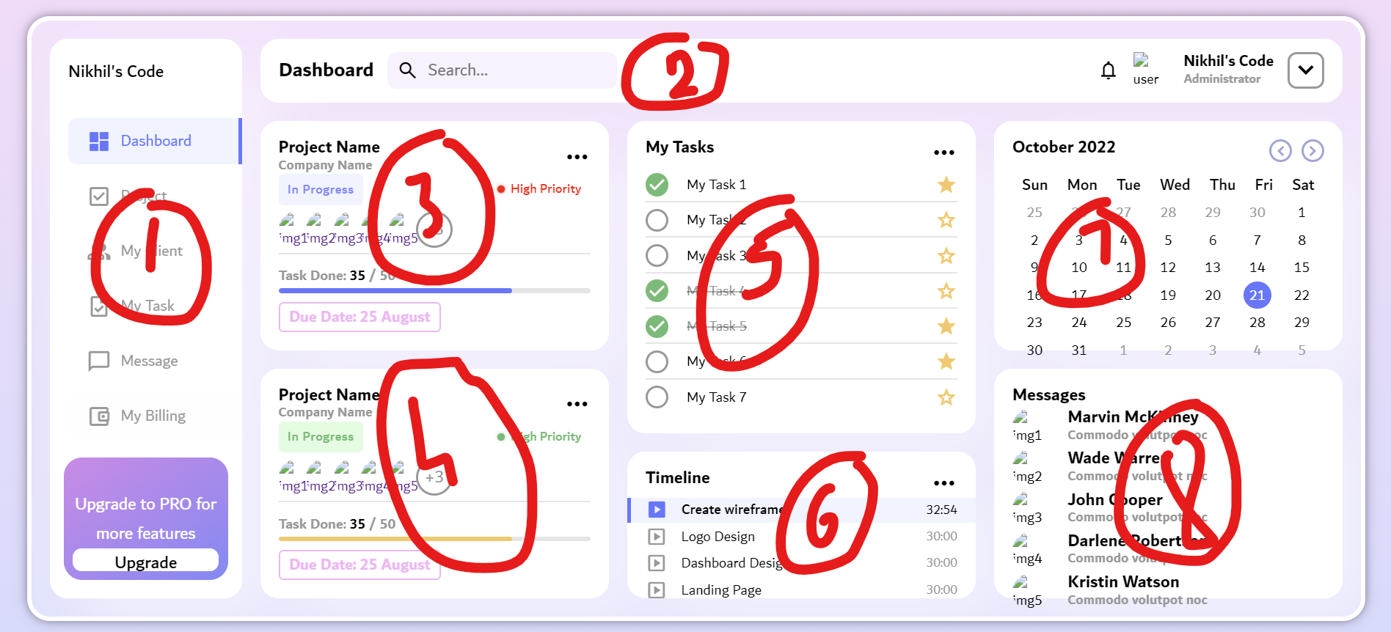

Abhinav:

Create a login/sign up page for the task manager

Also part 2 of the above sample code.

Evan:

Create a page to select workspace, add members or create new workspace

Also part 1 of the above sample code.

Bhaskara:

Complete part 3,4,5 of the above sample code.

Dhanusri Reddy:

Complete part 6,7,8 of the above sample code.

<https://www.youtube.com/watch?v=j-JVJEWL2aQ>

This is the model that we will be following.

Don’t worry about the integration of the code.

I am planning on creating a GitHub repository to host our project so that every one can contribute to it and see our work.